**Exercise 8.**

Use of Virtual Instruments

Table of Contents

List of Figures 1

Abstract 2

Part 1: Analysis and Synthesis Square-wave Signal 3

Part 2: Filtering Out Selected Harmonics of the Square-wave Signal 6

Part 3: Homework 10

# List of Figures

Figure 1 Measuring system connection 3

Figure 2 Function Input Oscilloscope Output. 4

Figure 3 FFT Operation. 4

Figure 4 Fourier Analysis. 5

Figure 5 Fourier Analysis Parameters. 5

Figure 6 adder with attached sources and oscilloscope 6

Figure 7 AC Analysis. 7

Figure 8 Fourier Analysis results. 7

Figure 9 Oscilloscope Perspective. 8

Figure 10 Before Filter. 8

Figure 11 After Filter. 9

Figure 12 THD Equation. 9

Figure 13 Fourier Transform THD 9

Figure 14 HWK Signal 10

Figure 15 Fourier Analysis 10

Figure 16 Tested Circuit 11

Figure 17 Fourier Transform of Tested Circuit 11

Figure 18 Oscilloscope Output 12

# Abstract

The aims of this laboratory exercise were to learn the basics of using NI Multisim 10 simulation program:

* Using virtual instruments in Multisim,
* Analysis and synthesis signals,
* Filtering and a Fourier analysis of selected signals.

# Part 1: Analysis and Synthesis Square-wave Signal

To begin this exercise, I will create a measuring system connection that is very basic. The function generator is an Agilent replica whilst the oscilloscope is a Tektronix replica. Below please see a diagram presenting the connection for the basic type signals we will measure/perform.

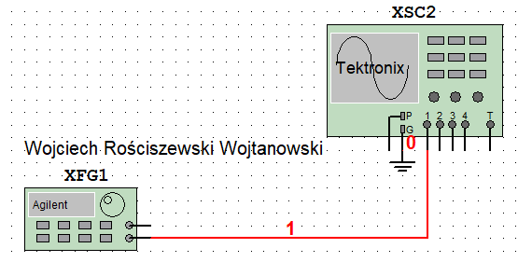

Figure 1 Measuring system connection

For the next part of the exercise we will implement a square wave signal analysis. To perform this please find the diagram below consisting of the connections.

The parameters used here was a square wave signal 1 VPP with the frequency 1 kHz. Simply we will insert the Function generator, draw the connecting from the output of the generator and we will call it out, and then simply connect out into CH1 of the oscilloscope. This has been done in the figure above. Now we must perform a Fourier analysis of our input signal and read the harmonic frequencies. To do this we will use the simulation options in the Multisim program, by selecting simulate -> analysis -> Fourier analysis. From this we will set the following input parameters for our analysis to run correctly. In the below please see a list of basic information for the settings used for this stage:

* Frequency Resolution: 1 kHz
* Number of Harmonics: 10
* TSTOP: 0.001 sec
* Display: Chart and Graph
* Vertical Scale: Linear
* Sampling Freq.: 110000 Hz

In the below please see the “real” function generator connected to the “real” oscilloscope. The Oscilloscope reads the 1VPP square wave generated by our function generator. What we observe? We observe on oscilloscope a 1V Pk-Pk reading, which confirms that our function generator is operating correctly and feeding the oscilloscope with an accurate signal. To set the image size as seen below I have used the Tektronix built in auto set feature to balance the scale quicker. This will be commonly used for readings in this report.

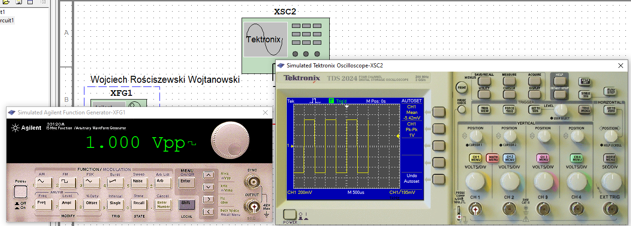

Figure 2 Function Input Oscilloscope Output.

For the next part of the exercise we must observe the Fourier transform, but how do we do this? The Tektronix oscilloscope has a built-in option FFT. FFT is Fast Fourier Transform, from which we can see the peaks of our signal therefore we will be able to for example calculate the distance between each peak, or how each peak change or we can calculate the THD (Total Harmonic Distortion). More on THD later in this report where I will describe it with some easy to interpret examples.

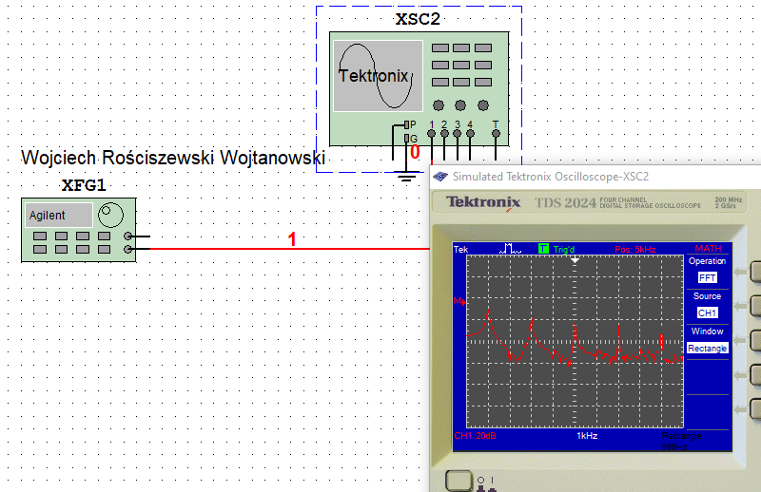

Figure 3 FFT Operation.

With the use of the built in cursors in the oscilloscope I had been able to read the values of the harmonics, wit the first harmonic being the strongest, at 1 kHz- makes sense and seems to be correct if where generating a signal at 1 kHz.

Next step we can perform the built in Fourier analysis in the program, this is done with use of the program itself instead of the build in “real” oscilloscope. See the figure below that presents the Fourier analysis results. To select our Fourier analysis option, it can be found in Simulate > Analysis > Fourier Analysis. We specify parameters and simulate the analysis of our system.

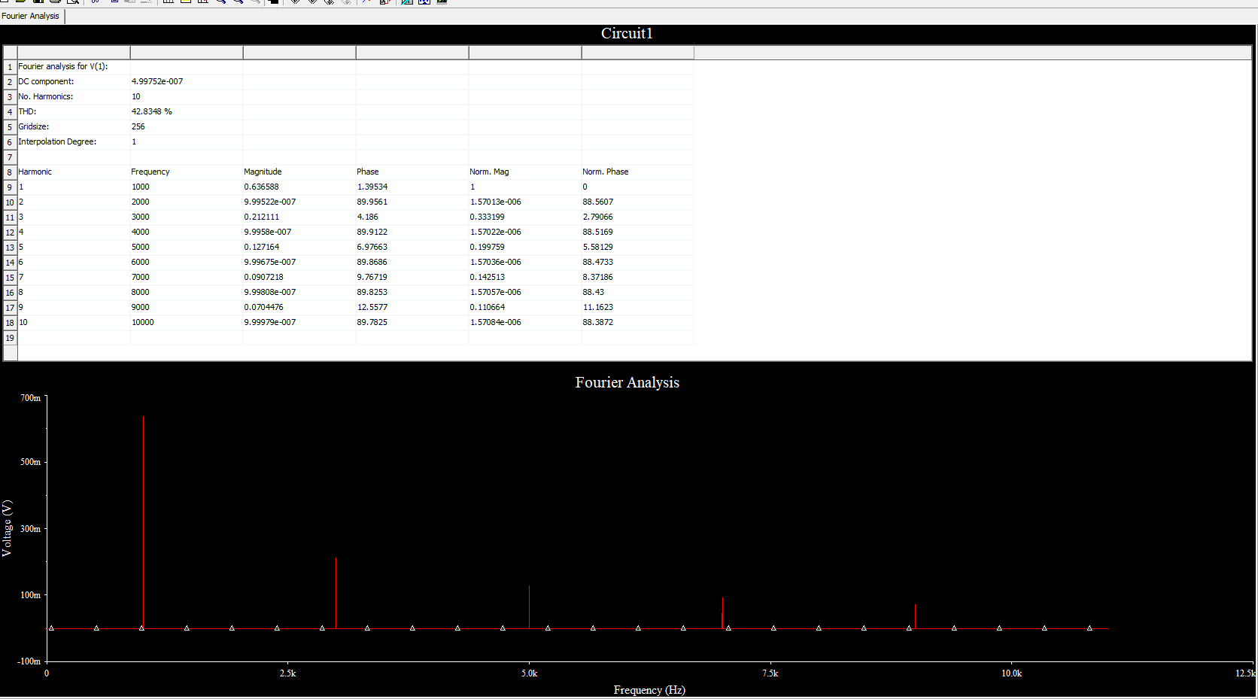

Figure 4 Fourier Analysis.

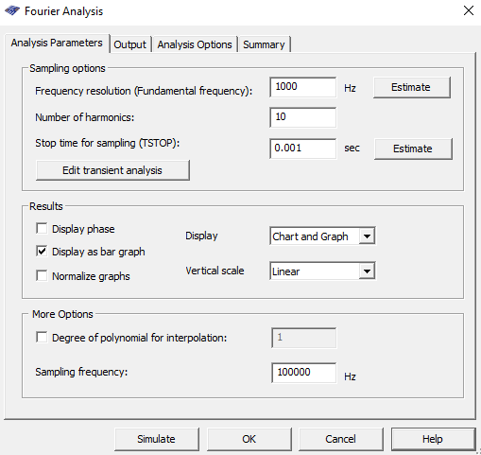

Figure 5 Fourier Analysis Parameters.

Conclusion is that we see where the harmonics of the signal are, so see in the figure the Fourier Analysis graphical plot where we see the all harmonics that are at the odd frequencies such as 1kHz, 3 kHz, 5 kHz, 7 kHz etc. From the provided results we are also able to read the values of each harmonic component individually, so it is like the oscilloscope cursors function but just more accurate or easier to use, because we have all information in front of us already measured. The values in the analysis (please seek the values above the graphical plot) we will find 10 harmonics because the reason it is 10 is because during specification of the analysis I have selected the number of harmonics to be displayed here, please see figure above presenting this.

# Part 2: Filtering Out Selected Harmonics of the Square-wave Signal

For this part of the exercise we will be cutting off the higher harmonics. For this we will design a passive low-pass filter that enables higher harmonics of the signal. The main goal of this simulation will be to remove each component that is any higher than the original value of 1 kHz, almost purifying the signal. For this particular purpose we can either refer to our filter design website to aid us, we know that we need to create a 2nd order Chebyshev 3 dB filter with the passband set to 1.2 kHz and stop band being in 9 kHz. Please see the figure below where we see that to build this circuit (filter) we must use 1 main amplifier, add two resistors and two capacitors to filter out the frequencies. Rest of the circuit is self-explanatory, this is a inverting added circuit (first five components are odd).

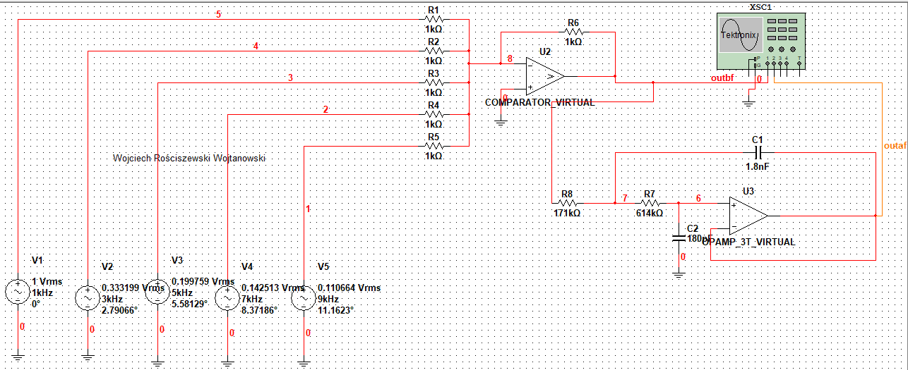

Figure 6 adder with attached sources and oscilloscope

Before filter:

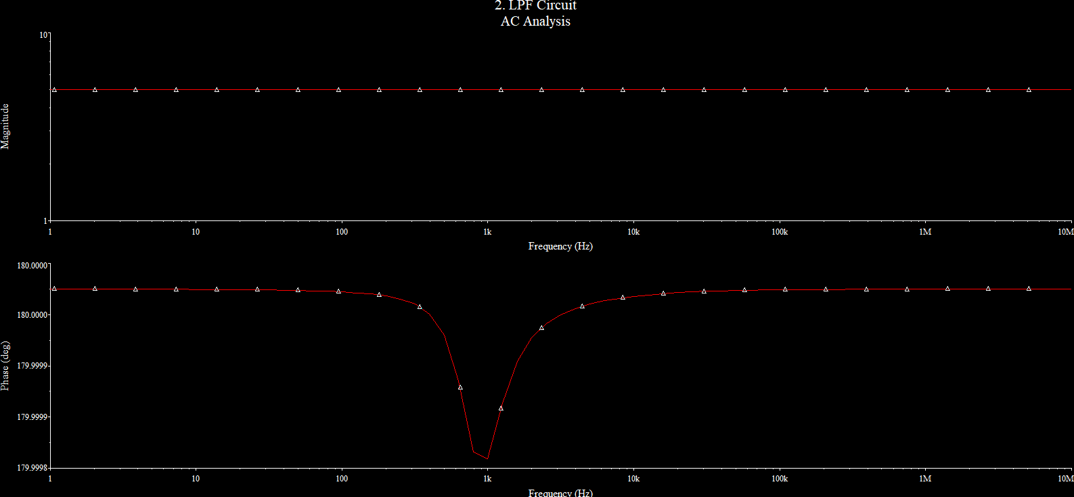

In the below please see the AC analysis of the signal where we can see the 3 dB drop.

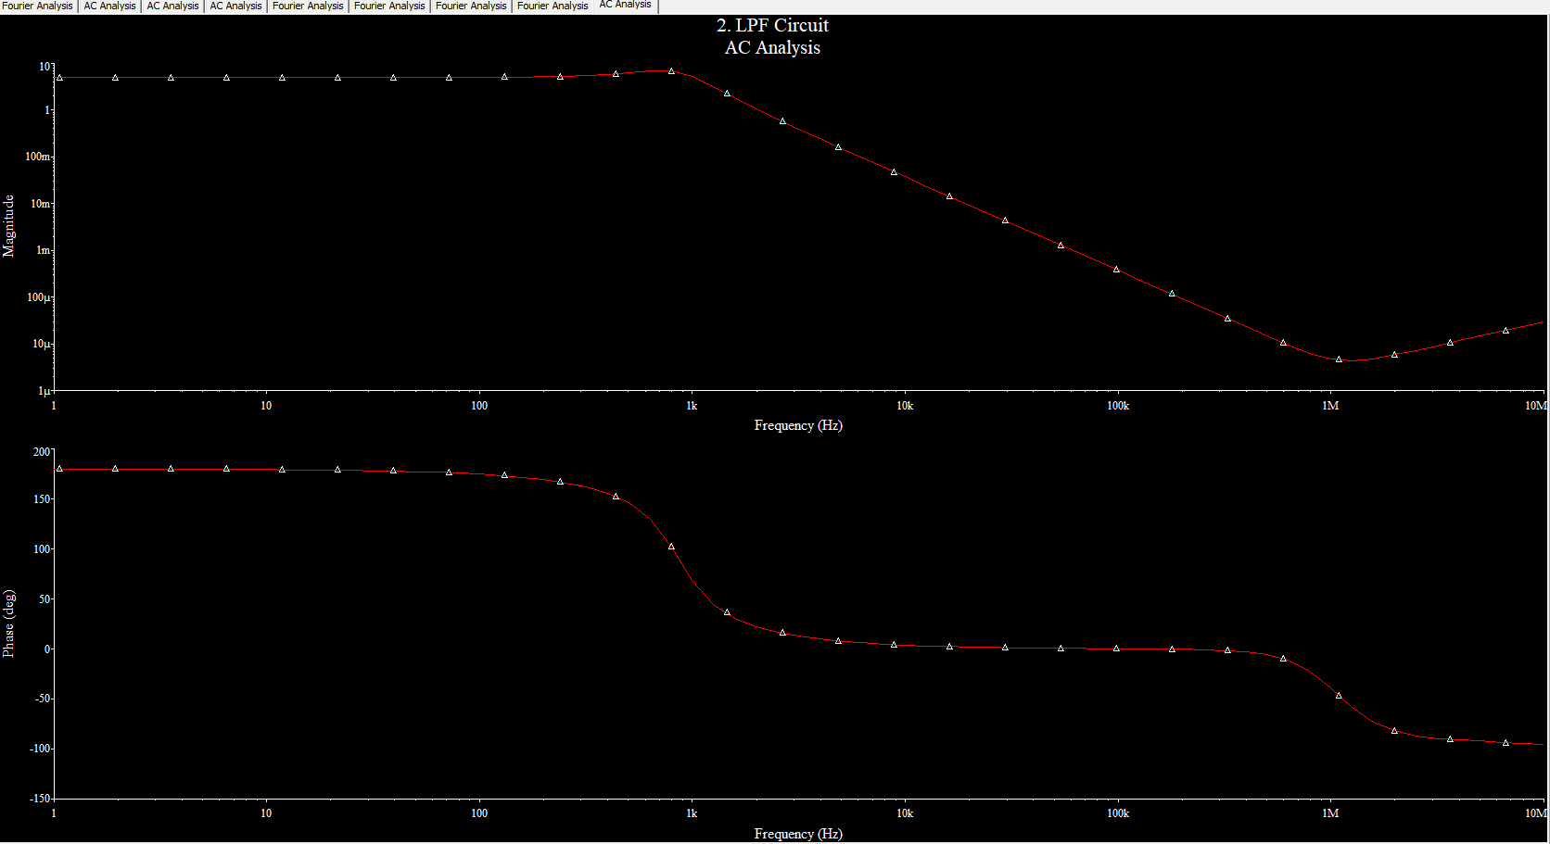

Figure AC Analysis.

Next, we will perform the Fourier transform analysis.

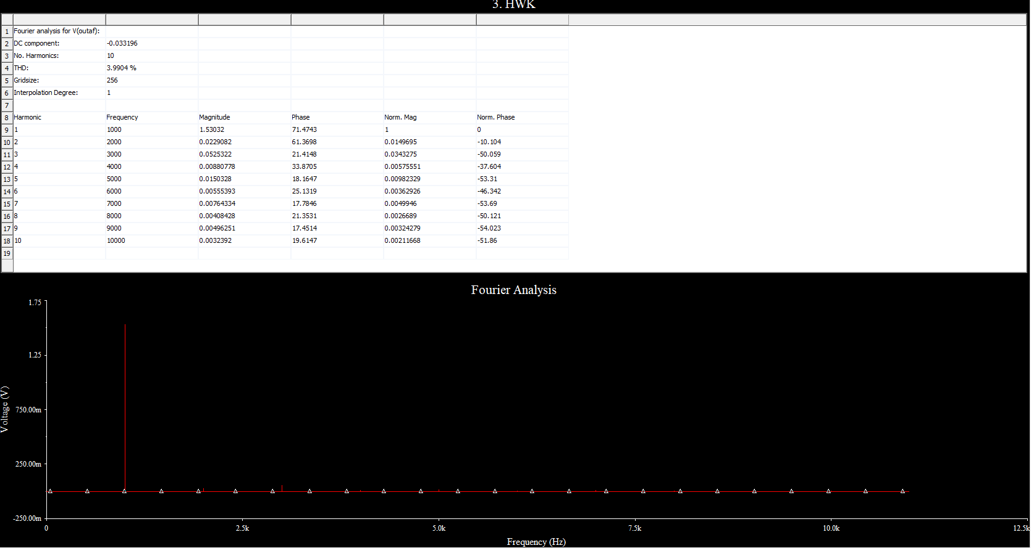

Figure Fourier Analysis results.

From the Fourier analysis we see that the filter is operating correctly, we see that only one of the signal components is at the frequency of 1 kHz rest of the components are < 1kHz.

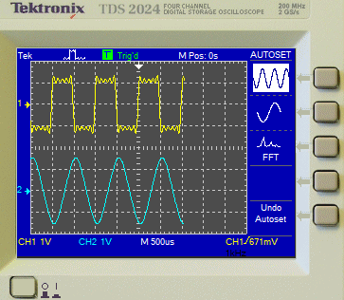

Figure 9 Oscilloscope Perspective.

In the figure below we see the oscilloscope window, we see the input signal (yellow-inverting adder) and the output signal (blue-output filtered of yellow). Filter is working correctly. We clearly see that the filter is a sinusoidal signal which is our basic harmonic of the yellow signal (original).

For the next part of the experiment we will calculate the Total Harmonic Distortion (THD). We will use the Distortion Analyzer included in the software or we can use the THD Equation.

Using the built in THD meter we see that the THD of our signal is at 3-4% after filtering however before filtering our THD is very big see figures below.  
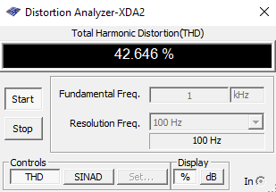

Figure Before Filter.

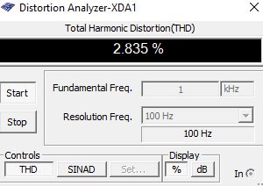

Figure 11 After Filter.

Using the THD equation:

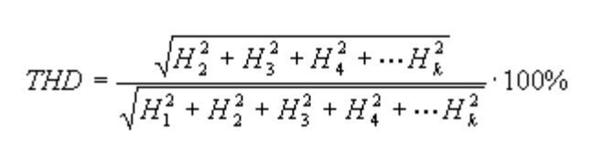

Figure 12 THD Equation.

When calculating the first 5 components (peaks of FFT) I receive a THD of 3.89% which seems close to what the meter presents. We can also perform Fourier analysis and read the values from there, the THD presented there is THD = 3.9904%.



Figure 13 Fourier Transform THD

We see that calculations are similar or close. Of course, we would like to keep as close to the original as possible.

# Part 3: Homework

The function generator has been set to a triangular wave with a 1VPP setting at a 1 kHz frequency, please see output. In the below please see the output of my signal:

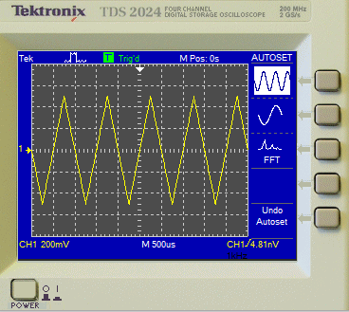

Figure HWK Signal

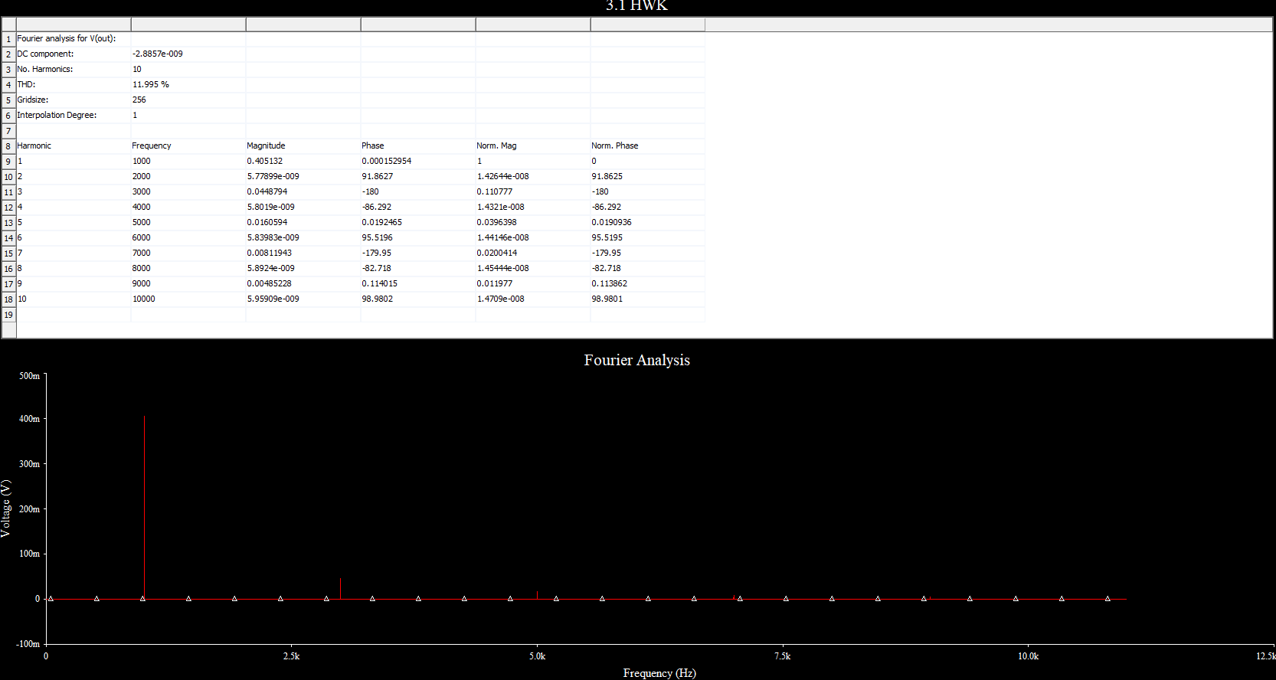

Figure 15 Fourier Analysis

In the below please see design of our filter and first five odd harmonics.

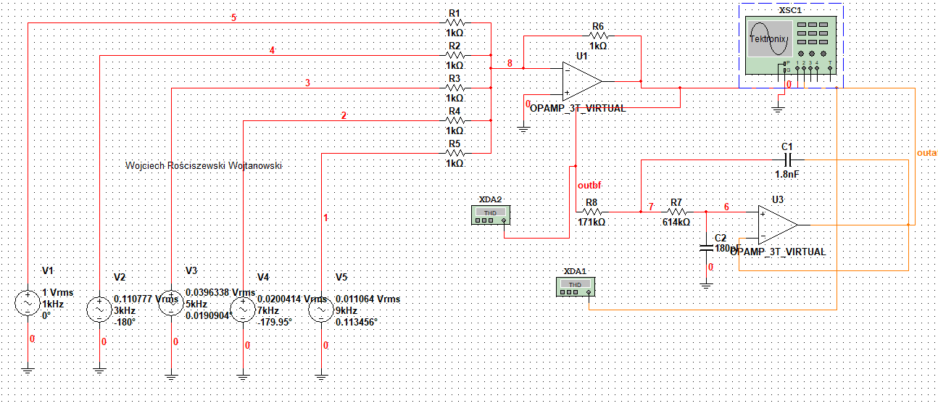

Figure Tested Circuit

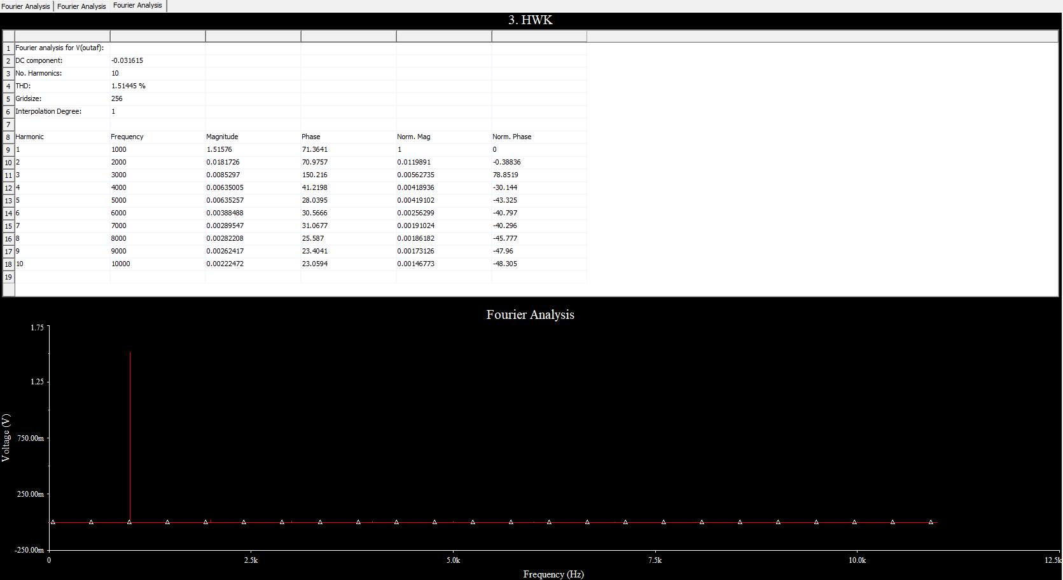

Figure 17 Fourier Transform of Tested Circuit

In the below please observe the output of the oscilloscope.

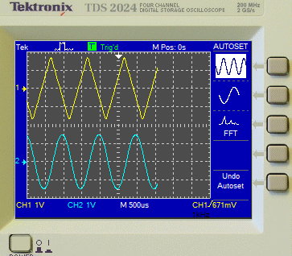

Figure Oscilloscope Output

Conclusion, inverting adder is in the yellow signal of the figure above and the blue signal is by the low-pass filter, where we get rid of the harmonics that are different from the first harmonic.

From the Fourier analysis we get THD = 1.51445

From the Equation THD = 1.55%

In conclusion the triangular signal has a smaller THD than the signal we performed in the exercise before. The power sources are not ideal please take this into account however the results are quite promising, so this can be only a theoretical approach/demonstration of how to do such simulations. In real world the results would be different due to temperature coefficients affecting components, cables, generators. We can only simulate and **predict** what the desired output could potentially be.